**How to start with git/bitbucket**

Download and Install git bash for windows (<https://gitforwindows.org/>)

Right click on the project you want to push github/bitbucket and open with git bash

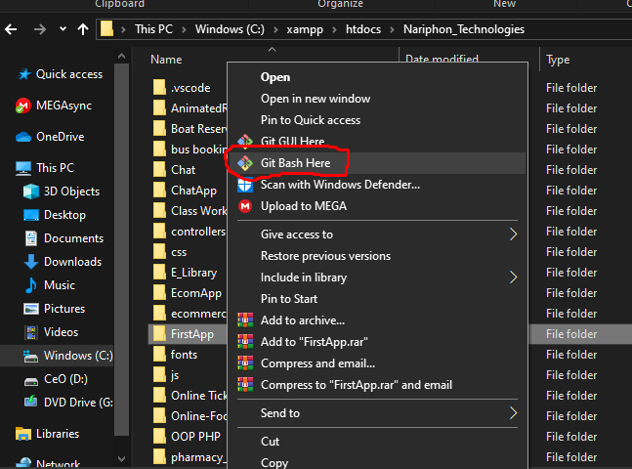

Git bash command tool will help you communicate with your online GitHub account. Therefore, for you to communicate to your online account/repositories, you have to login in your git bash tool :

Login Process:

Run this command *git config --global user.name 'CleoCTech'* to link to your git account if you have one, if not create first.

Link your mail too *git config --global user.email 'cleophasomwenga292@gmail.com'*

Now you have linked your git or bitbucket account.

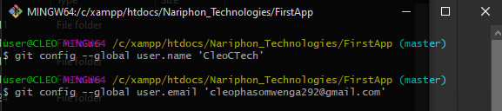

Create a repository in your account

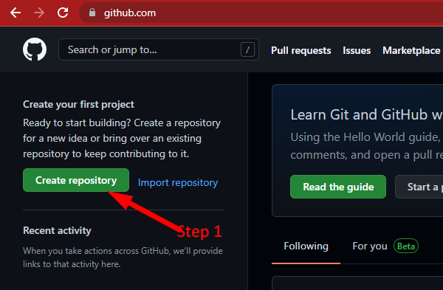

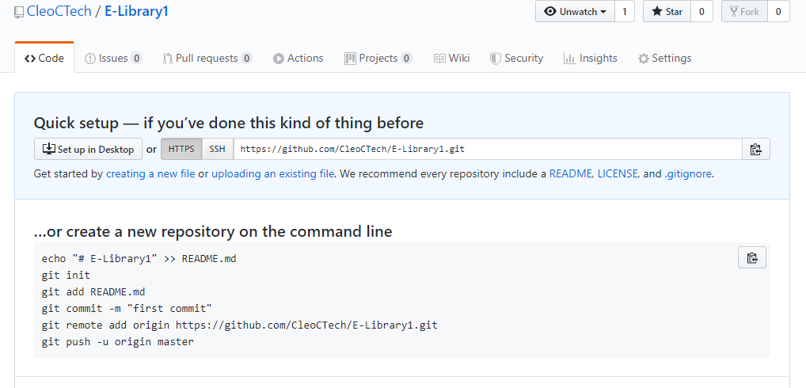

Open your folder directory with git bash tool

Initialize git with this command (In other words you are telling your folder you want to invite git to work on you).

*git init*

The next step, you want to commit/stage your files. This is helpful because you can navigate back to this stage and have a look on how files were. Supposing there will be couple of changes in future. You can say you are pushing this files online with a tagged message.

*git commit -m “Initial files from cleo”*

Make sure you are in the main branch sometime called master branch. You will see the master branch being initialized once you run git init command.

*git branch -M master*

The next step is to add your git repo link to tell your files where to go every time you will be making changes and pushing them. Run this command: NB, the link is unique according to your account and repo name.

git remote add origin https://github.com/Geekariuki/_From_Cleo.git

The last step is to push the files to your GitHub repository with this command:

If you are pushing them for the first time use this:

*git push -u origin master*

Else:

*git push*

Run the above command to push the code.

**What if you want to push both git hub and bitbucket?**

You will have to rename your origin remote from either bitbucket to git or git to bitbucket

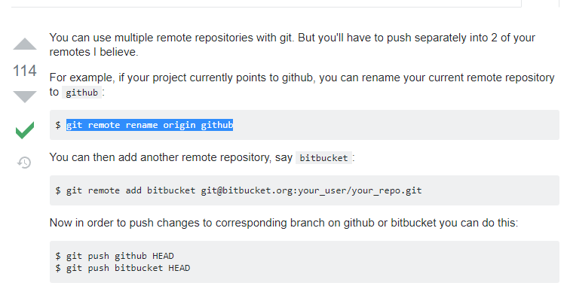

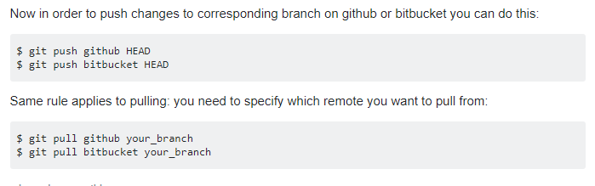

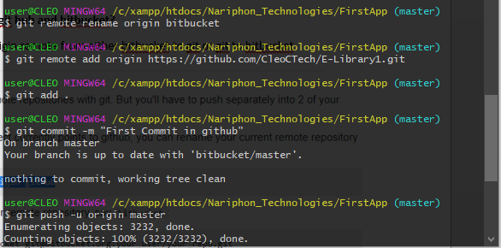

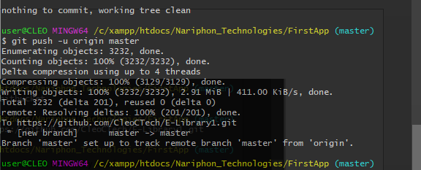

**What if you have renamed your repository?** For example from: <https://github.com/CleoCTech/E-Library1.git> to: <https://github.com/CleoCTech/E-Counseling.git>

And you want to rename/ the remote URL in local git config.

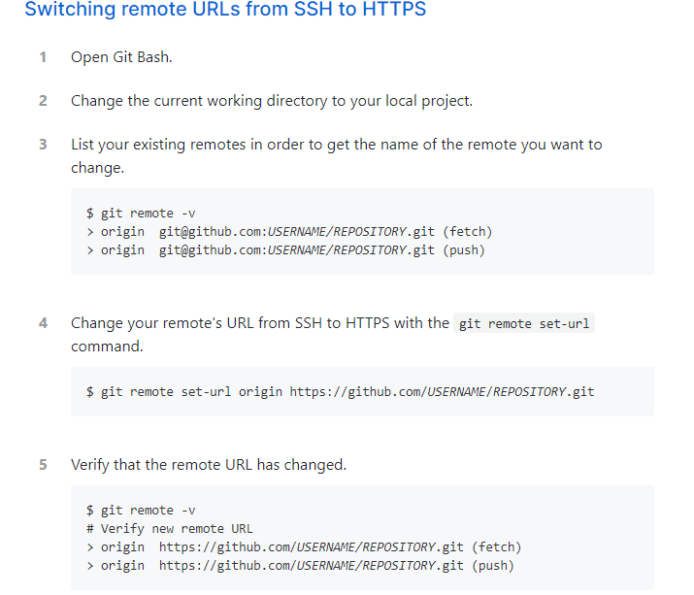

Example as below

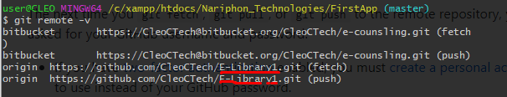

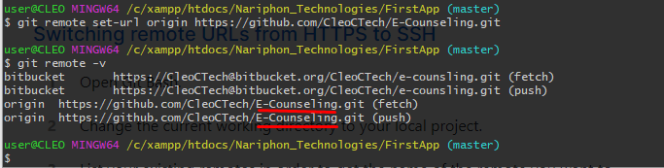

What if you want to remove some remote that are listed above

Do the following: I.e *git remote rm bitbucket (to remove bitbucket repo)*

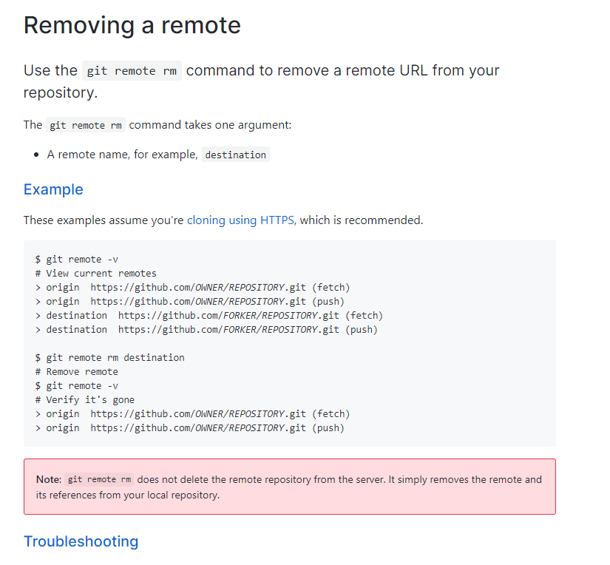

How to delete folder

